Lecture 9

**NFS-Server2-and-FTP**

* As CentOS 6 repository is EOL (end-of-life) or discontinued (official support is ended)
* It can be done manually by mounting DVD or ISO
  + In ISO 🡪 packages directory keeps packages
  + 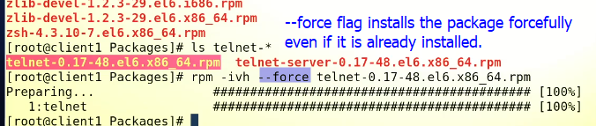
* To fix yum on CentOS 6 from Repository
* We can use CentOS-vault repository.
  + Move all repo files in yu,.repos.d to some other location
  + Create a repo file with $ touch vault.repo
  + <https://www.getpagespeed.com/server-setup/how-to-fix-yum-after-centos-6-went-eol#:~:text=Use%20the%20CentOS%20Vault%20repository&text=x%2C%20you%20can%20simply%20point,ever%20be%2C%20which%20is%206.10.&text=That's%20it%2C%20everything%20should%20be,the%20file%20%2Fetc%2Fyum>.
  + Copy [repo file](https://d.docs.live.net/578de8d3e1dbb24d/DevOps%20Advancement%20Track/Al%20Naf-%20RHEL%20Intensive/4.%20Services/CentOS6-vault.repo.txt) and paste into vault.repo
  + By this way **yum** will start working in CentOS 6
* .

NFS (Network File Service)

* 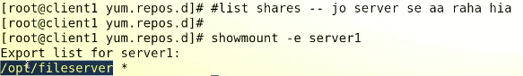
* Instead of service1 there could be <IP> or full domain i.e server1.alnafi.com
* To check 🡪 $ df -Th /myshares
* 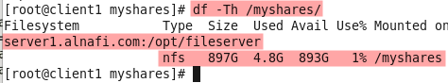
* We cant create files from client
* A picture containing text

  Description automatically generated
* It is because NFS is not allowing it.
* So 🡪 go to server
* 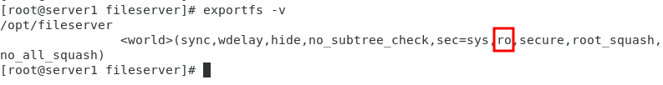
* It is set to “ro” read only mode.
* To change the permission
* $ vi /etc/sxports
* 
* $ exportfs -r 🡪 to reload this file into RAM
* $ exportfs -v 🡪 to check
* 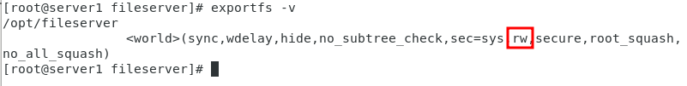
* On client if a new file is again tried to create
* A picture containing text

  Description automatically generated
* Error message changed 🡪 Permission Denied
* The data towards NFS server is 🡪 it checked the file system permission in NFS
* NFD also checks permission of shared directory /opt/fileserver 🡪 here is the problem.
* 
* This directory needs to be fixed and permission is ti be changed
* $ chmod 777 /opt/fileserver
* 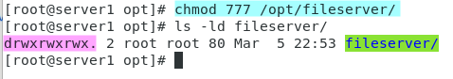
* Now on client
* 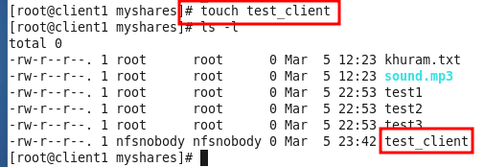
* Now client can write date on /myshares to /opt/fileserver on server1
* 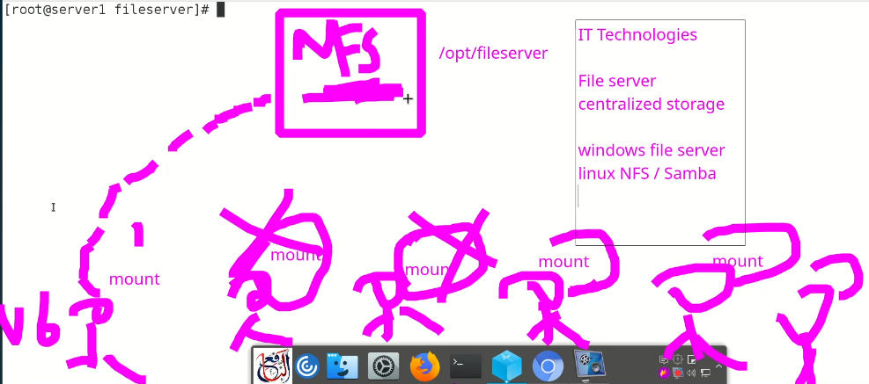

**FTP (File Transfer Protocol)**

**Works on**

* TCP/UDP on Layer 4
  + If a service or application requires credentials (Username & Password)
  + It means it works on TCP Protocol.
* Point to remember,

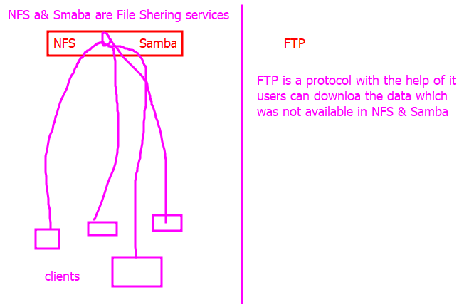

* Main difference is in FTP client can download the data because the data is on client’s hard drive. Clients can also upload the data to FTP server.
* In NFS & Samba data is on server side not on clients hard drive.
* 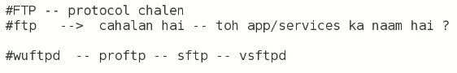
* Sftp 🡪 secure FTP
* Vsftpd 🡪 very secure FTP
* Mostly **sftp** is used in industry
* We are going to learn **vsftp**
* FTP 🡪 ports 21 & 20
  + 21 for connection
  + 20 for data transfer
* “ftp package” is required
* $ yum search vsftpd

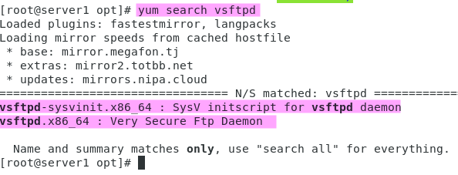

* $ yum info vsftpd

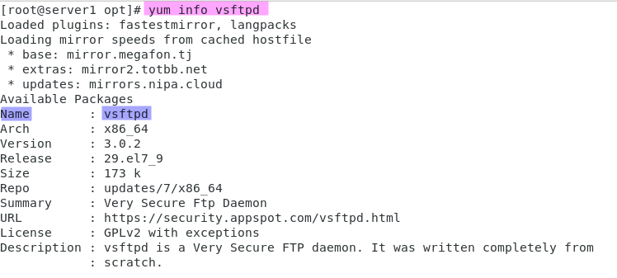

* $ yum list | grep -I vsftpd
* $ yum install vsftpd
* $ yum whatprovides vsftpd
* 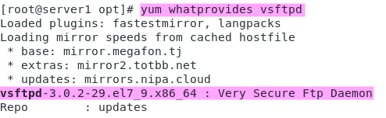
  + Try all these commands in “yum”.
* $ yum install vsftpd-* -y
  + The "vsftpd-*" wildcard specifies that all available packages starting with "vsftpd-" should be installed, which includes the main vsftpd package as well as any additional packages or plugins that may be available.
  + The "-y" option instructs yum to assume yes and automatically answer "yes" to any prompts or questions that may be presented during the installation process..
* **Tip:-** Sir Kazim looked into yum.repo.d because yum was not working
* He used $ ls -lrth 🡪 to list which repo file is being accessed first
* Then he found a local.repo file
* He renamed it with “mv” command
* $ mv local.repo.txt 🡪
* It fixed the problem and “vsftpd” package installed from internet from other available repo files which were BaseOS-.repo
* 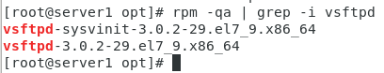
* Now enable at the time of boot
* **$ systemctl start vsftpd**
* **$ systemctl enable vsftpd**
* 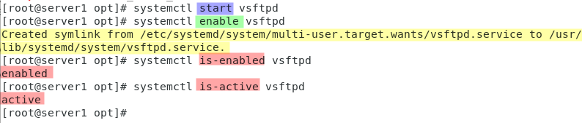
* **How to check port is opened (Port No. 21)**
* Text

  Description automatically generated

To end a telnet session, you can use the following steps:

1. Press the Ctrl + ] key combination to enter the telnet command prompt.
2. Type the command "quit" or "exit" and press Enter. This will terminate the current telnet session and return you to the local shell prompt.

* Another way,
* $ nc 127.0.0.1
* Another way
* $ ss -tulnp | grep -1 21
* 
* **Default path for “FTP” 🡪 /var/ftp**
* 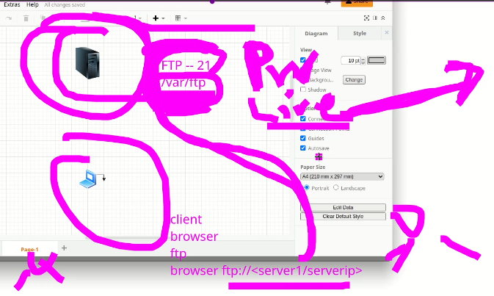
* In local environment private IP is used
* But in production environment Live IP is required.

**Lets check it in client**

* Open browser
* In URL bar 🡪 <ftp://server1>
* 